RESUME
Anusha U Hiremath
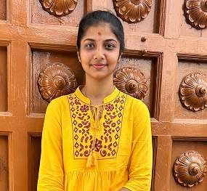
Mob.No. 8618261300 auhiremath2002@gmail.com
CAREER OBJECTIVE
To work in a challenging atmosphere by exhibiting my skills with utmost sincerity and dedicated smart work for the growth of your esteemed organization along with mine.
PERSONNEL STRENGTH:
- Good communication skill
- Good presentation skill
- Good grasping power
- Leadership quality
- Willing to work in teams
- Hardworking
SOFT SKILL:
- C
- C++
- Data Structure
- Java
HOBBIES:
- Reading Books
- Listening music & Dancing
- Cooking
- Playing Carrom

BASIC ACADEMIC CREDENTIALS :

EXAMINATION | UNIVERSITY | INSTITUTION | PASSING YEAR | PASS %  (Aggregate)
BSC  (P M Cs) | Karnataka University, Dharwad | Karnatak Science College, Dharwad | 2023 | 80
PUC | Department of Pre-university | JSS R S Hukkerikar Commerce & Science College, Dharwad | 2020 | 72
S.S.L.C | Karnataka Secondary Education | Shanti Sadan High School, Dharwad | 2018 | 83.68

PERSONAL DETAILS :

Gender : Female
Father Name : Umesh M Hiremath
Mother Name : Maheshwari U Hiremath
Marrital Status : Bachelor
Address : D/O Umesh Hiremath, Kumareshwara housing society
3rd stage, Yalakki shettar colony, Dharwad-580004

Cast And Category : 3B

I here by declare that given information is true.

Date: Signature
Place: Dharwad Anusha U Hiremath

